4th April 2016

**Exciting Motorsports as FIA WTCC Season begins**

The excitement on track is back at the FIA World Touring Car Championship, which boasts the Japanese Tyre manufacturer YOKOHAMA as its Official tyre supplier. The season began at the Paul Ricard circuit in France at the weekend, and although the defending Champion, Citroen Racing’s Jose Maria “Pechito” Lopez managed a lights to flag win on race 2, following a fantastic pole position qualifying run, Honda’s Rob Huff also presented his credentials and challenge to the throne with a superb victory in race 1.

Following months of preparation from the teams and manufacturers, as indeed from the drivers to be physically and mentally ready to confront the long season ahead, the Championship is back with new elements at the highest level of competition which promises to enthuse fans around the world.

Three main manufacturers with works teams, Citroen, Lada and Honda will also compete for the new MAC3 (manufacturers against the clock) time trial which is inspired by professional cycling events such as the Tour de France, whereby three manufacturer cars per team must compete to achieve the fastest overall time. Although Volvo Polestar is the fourth manufacturer within WTCC this year, at the moment they are fielding 2 cars and are therefore not eligible to participate in the MAC3.

The first race weekend at Paul Ricard certainly gave everyone something to discuss and cause for celebration to many others. Newcomer to the FIA WTCC Volvo Polestar’s Swedish Champion Thed Björk impressed with a superb display which brought him from last place in the grid to 7th, offering a taster of potential good things to come his way. Citroen sporting a bright red car and back to the winning ways of the Argentine master of the last two Championships, “Pechito” Lopez with four times World Champion Yvan Muller following closely. The British racing dynamo Huff, now in the ranks of Honda and teaming up with Monteiro and Michelisz all augur well for the thrills and spills of the competition ahead. For their part Lada have also lined up a new team which has brought Italian veteran Tarquini together with Nicky Catsburg and Hugo Valente aiming to present real competition this season.

Although conceding this year will be even more difficult than in the past, Jose Maria Lopez leads the drivers’ standings on 38 pts, followed by Thiago Monteiro on 34 pts and Rob Huff on 33 pts. In the Manufacturers Championship, Honda now lead for first time since 2013.

**FIA WTCC Calendar 2016**

1. France / Le Castellet 03 April

2. Slovakia / Pressburg 17 April

3. Hungary / Budapest 24 April

4. Morocco / Marrakech 08 May

5. Germany / Nürburgring 28 May

6. Russia / Moscow 12 June

7. Portugal / Vila Real 26 June

8. Argentina / Termas de Rio Hondo 07 August

9. Japan / Motegi 04 September

10. China / Shanghai 25 September

11. Thailand / Buriram 06 November

12. Qatar / Losail 25 November

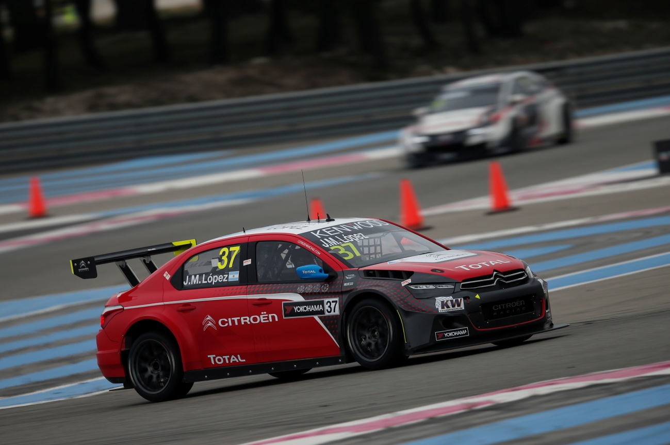

*Lopez's Red Citroen*

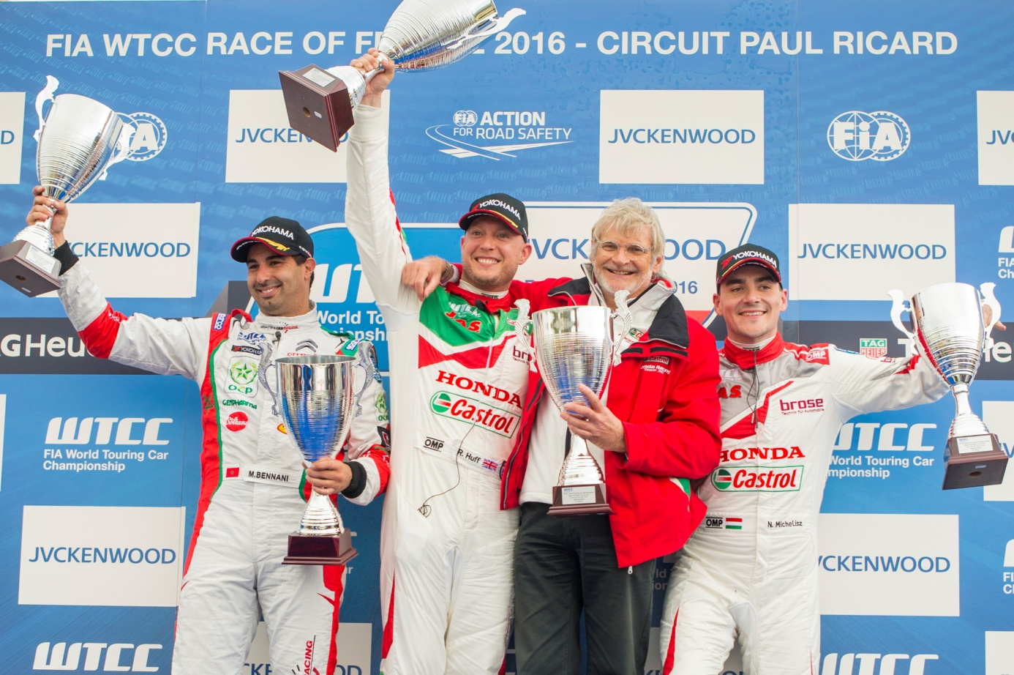

*Rob Huff celebrates victory at WTCC France*

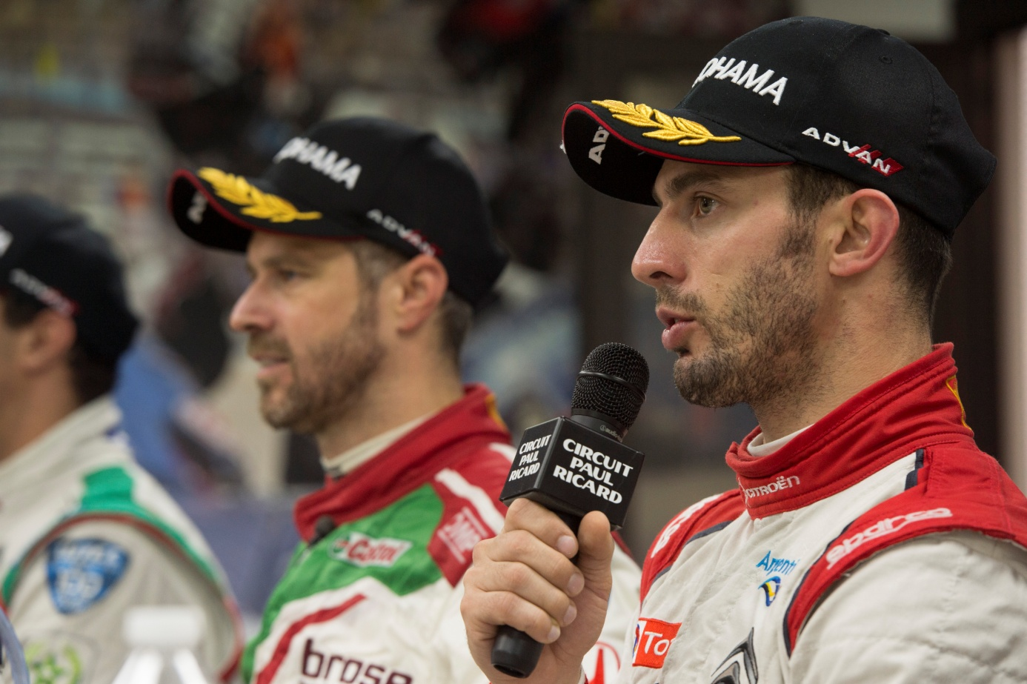

*Race 2 Winner Lopez during Press Conference with Monteiro next to him*